# Section 19.3: Final Journey of the Buddha – Phase 3: Reaching Pāṭaligāma and Crossing the Mighty Ganges

In the previous section (19.2), we followed the Blessed One and his venerable Saṅgha as they spent time in and around Rājagaha, meeting royal messengers and offering uplifting teachings for the benefit of the monastic community. We then traced the footsteps of the Buddha as he departed from the city, passing through the Royal Guest House at Ambalaṭṭhikā and continuing onward to Nāḷandā. Having stayed in Nāḷandā as long as he wished, the Blessed One said to the Venerable Ānanda, “Let us go to Pāṭaligāma.”  
And so they departed together with the Saṅgha.[1]

## Arrival at Pāṭaligāma (Present-day Patna, Bihar)

At the time of the Buddha, Pāṭaligāma was not yet a major city, but it served as a significant river port within the Kingdom of Magadha. In later centuries, it grew in importance and became known as Pāṭaliputta, the capital of Emperor Asoka’s great empire. During the British colonial era, the area continued to flourish as a major trade centre. (See Section 19.1 for more historical context.)

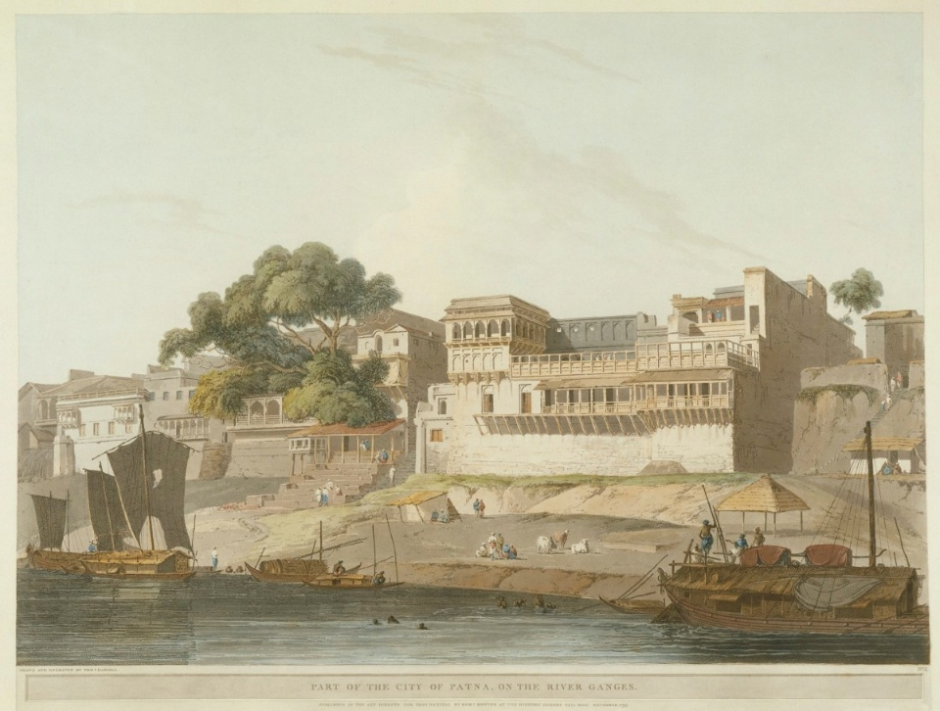

**Patna on the River Ganges (During the time of the British Rule in India)[2]**

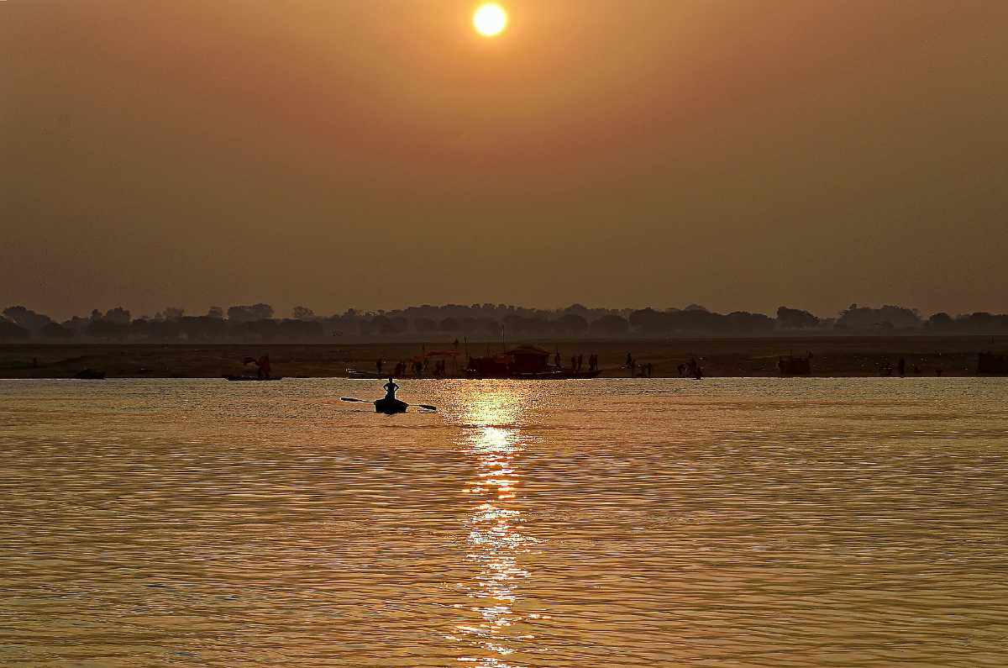

**River Ganges at evening twilight [3]**

## A Dhamma Teaching for the Householders of Pāṭaligāma

Upon hearing that the Blessed One was approaching their village accompanied by a large Saṅgha, the lay-followers of Pāṭaligāma were filled with joy. Eager to welcome the Buddha and the monks, they prepared a rest house — cleaning it thoroughly and arranging all that was needed.

As evening approached, the villagers lit oil lamps, placed pots of water for foot-washing, and arranged suitable seats for the Blessed One and the Saṅgha. When everything was ready, they humbly invited the Buddha to enter and rest there. Out of compassion, the Blessed One accepted their invitation.

Seated among the villagers, the Buddha addressed them with wisdom and care:

“Householders, there are these **five dangers for one who is immoral**, who fails in virtue.

1. *He suffers great loss of property through neglect of his affairs.*
2. *He gains a bad reputation for immoral and improper conduct.*
3. *He becomes shy and fearful in any assembly — whether of Khattiyas, Brahmins, householders, or ascetics.*
4. *He dies in confusion.*
5. *After death, he is reborn in a woeful state, a bad destination, in suffering and hell.”*

Then the Blessed One continued:

“Householders, there are these **five benefits for one who is virtuo**us, who succeeds in morality.

1. *By careful attention to his affairs, he gains great wealth.*
2. *He earns a good reputation for moral and wholesome conduct.*
3. *He approaches any assembly — whether of Khattiyas, Brahmins, householders, or ascetics — with confidence and ease.*
4. *He dies unconfused, with peace of mind.*
5. *After death, he is reborn in a happy destination, a heavenly realm.”*

The Blessed One then instructed, inspired, and gladdened the lay-followers of Pāṭaligāma with profound Dhamma teachings, continuing far into the night. When it was late, he said:

*“Householders, the night is nearly over. Now it is time for you to do as you think fit.”*

Filled with joy and gratitude, the villagers paid homage to the Blessed One and the noble Saṅgha. Having seen the Buddha and listened to the sweet and profound Dhamma, their hearts were uplifted. With reverence, they quietly departed.

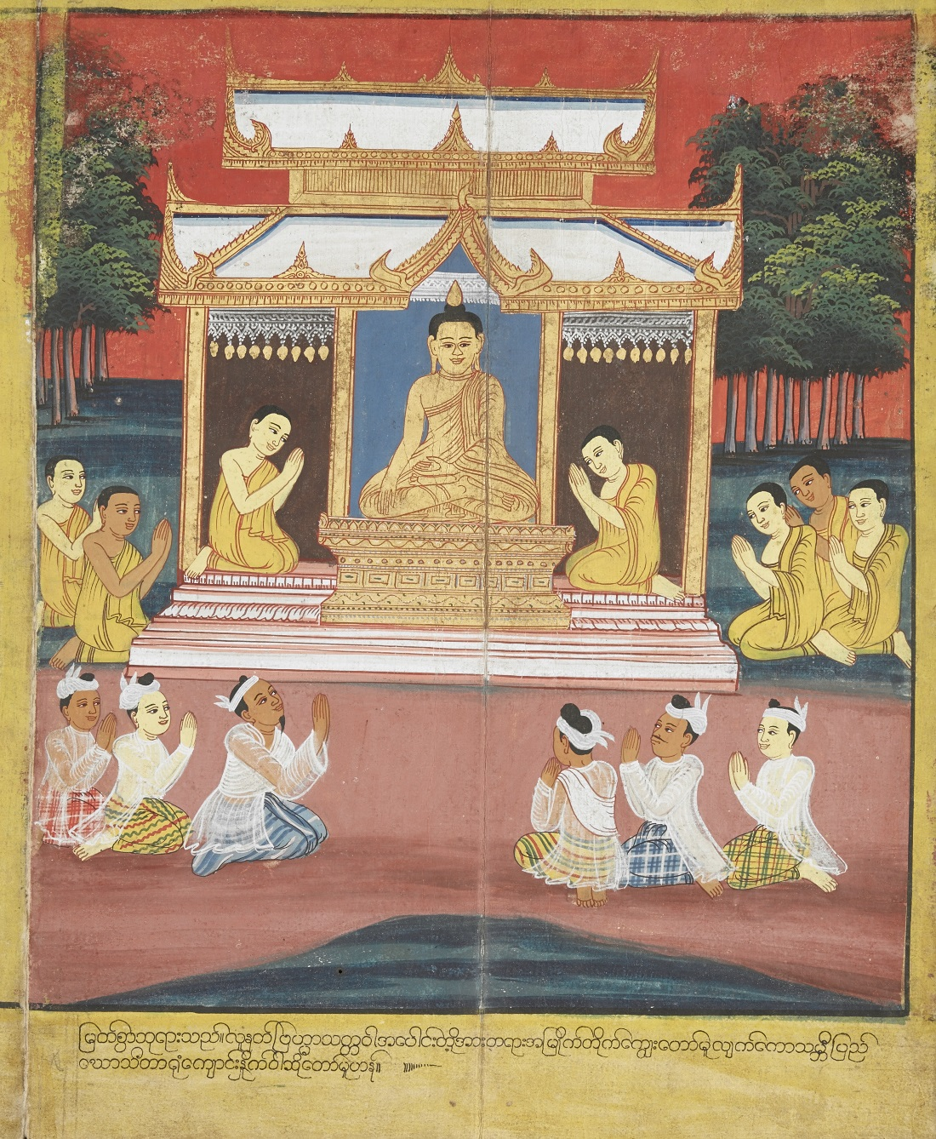

**Pataligama Villagers listening to the Buddha [4]**

### **The Buddha Foretells the Future of Pāṭaligāma**

At the break of dawn on his first day in Pāṭaligāma, the Blessed One, with his divine eye that surpasses all human vision, beheld a wondrous sight: thousands of devas arriving to take residence in that town. Turning to the Venerable Ānanda, he asked:[5]

*“Ānanda, who is building a fortress here at Pāṭaligāma?”*

Ānanda replied,

*“Lord, it is Sunidha and Vassakāra, the Magadhan ministers. They are constructing a fortress as a defense against the Vajjians.”*

Then the Blessed One declared:

“Ānanda, it is as if Sunidha and Vassakāra had taken counsel with the Thirty-Three Gods themselves.

“For I have seen with my divine eye how countless devas are settling here.  
Know this, Ānanda: as far as the noble Ariyan realm stretches, as far as its trade and prosperity reach, this place will become the chief city—Pāṭaliputta—spreading its influence far and wide.  
Yet, Ānanda, Pāṭaliputta will face three dangers: from fire, from water, and from internal strife.”

### Alms Giving of Ministers Sunidha and Vassakāra

Later, the ministers invited the Blessed One and the Saṅgha to their residence for the mid-day meal. They prepared a refined feast of both hard and soft foods, offered with heartfelt devotion. After the meal, the Blessed One expressed his gratitude through a radiant verse of *anumodanā*—rejoicing in their meritorious act:

*“In whatever realm the wise make their home,*  
*Let them nourish those who live the holy life.*  
*The devas who witness such offerings will honour them in return,*  
*They will guard them as a mother guards her only child.*  
*And truly, the one whom the devas guard, lives in happiness.”*

This was the last discourse given by the Blessed One in ancient Pāṭaligāma—overflowing with compassion and guiding householders toward generosity, a virtue that brings happiness in this life and in lives yet to come.

Joyfully moved by the Buddha’s words, Sunidha and Vassakāra paid homage. When the Blessed One rose and prepared to depart, the ministers followed him, saying:

*“Whichever gate the ascetic Gotama departs through today, let it be known as the Gotama Gate (Gotamudvāra). And whichever ford he uses to cross the sacred Ganges, let it be called the Gotama Ford (Gotamatittha).”*

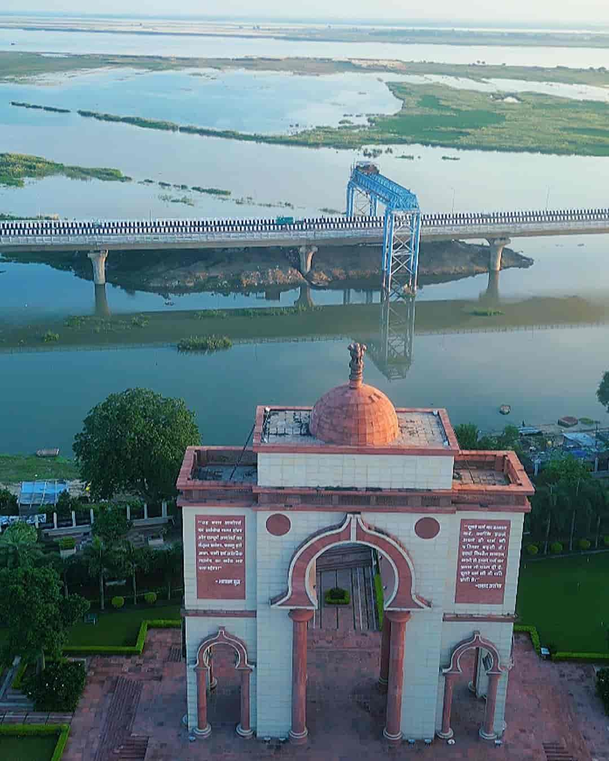

**Sabhyata Dwar in Patna- Gateway to the Ganges [6]**

### A Note on Pāṭaligāma’s Legacy

Today, Pāṭaligāma is known as Patna, the capital of Bihar. While the exact locations of the ancient Gotama Gate and Gotama Ford have not been identified, the spirit of that sacred encounter lives on. Near the banks of the Ganga, Patna now features the *Sabhyata Dwar*—the Civilization Gate—a grand sandstone arch that echoes the city’s ancient glory. Though not directly linked to the Buddha’s visit, its Mauryan-inspired architecture stands as a reminder of the deep spiritual and cultural roots of this region. **[7]**

## The Buddha and the Sangha Cross the Mighty River Ganges

The River Ganges, as it journeys through the northern plains of India, is joined by numerous tributaries and streams, gradually widening until, near present-day Patna, it stretches over four kilometres (2.5 miles) across. In modern times, bridges such as the Gandhi Setu (Ganga Setu) span this mighty river, linking the southern city of Patna to the northern region of Haripur in Bihar. This impressive structure, 4.56 km long, [8] stands as one of the longest river bridges in India. But in the time of the Blessed One, there were no bridges—only the flowing waters, ferries, and the compassion of boatmen.

Throughout his long teaching mission, the Blessed One is said to have crossed the Ganges many times, each occasion filled with meaning and spiritual resonance.

**The first crossing,** though unrecorded, likely took place when the young ascetic was making his way southward to Rājagaha. It is possible he passed through Pātaligāma, a village that would one day become Pāṭaliputta. With no money and newly embarked on his path of renunciation, the ascetic might have relied on the kindness of a humble boatman who, moved by compassion, ferried him across the river without charge. At this stage, he had not yet cultivated the meditative mastery to traverse the river through supernormal means.

The **second significant crossing came** soon after his enlightenment, as the Buddha journeyed with great compassion to the Deer Park at Isipatana to share the Dhamma with the five ascetics who had once supported him during his austere practices. Following the ancient route from Gaya to Varanasi, he approached the sacred city, which lies along the Ganges, a natural point of crossing. Tradition holds that a boatman refused to take him without payment, and since the Blessed One carried no possessions, the request could not be met. Yet he did not argue or demonstrate displeasure. Instead, he simply crossed the river through his supernormal power—swiftly and serenely, not to impress or astonish, but as an expression of pure resolve and self-mastery. Witnessing this, the boatman was said to be so moved that he reported the event to the king, who then declared that all ascetics should henceforth be allowed to cross the river freely. [9]

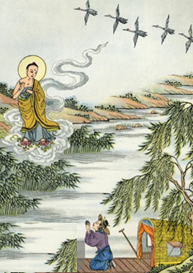

**The Buddha Crossing the Ganges River near Varanasi [10]**

**In another instance**, recorded in section 14.3, we see how deep the reverence for the Buddha had grown. During a devastating epidemic in Vesālī, the Buddha and the Sangha were invited by the Licchavīs to bring solace to the city. King Bimbisāra, with great devotion, arranged for a royal barge to ferry them across the Ganges from Pātaligāma. He lovingly accompanied the Blessed One to the river’s edge and waited in the barge until the Buddha and Sangha arrived. This episode reflects the honour and faith the people of the time placed in the Buddha, who had become a beacon of healing and wisdom in a suffering world.

And yet, it is **the final crossing of the River Ganges**—poignant and profound—that remains etched in the heart of the Dhamma tradition. It took place during the Blessed One’s last journey northward. By then, the rulers of Magadha, including King Ajātasattu and his ministers Sunidha and Vassakāra, resided at Pātaligāma. Yet no arrangements were made by them for the Blessed One’s passage.

Here is how the scriptures describe this moment:

*“And then the Lord came to the River Ganges. And just then, the river was so full that a crow could drink from it. And some people were looking for a boat, and some were looking for a raft, and some were binding together a raft of reeds to get to the other side. But the Lord, as swiftly as a strong man might stretch out his flexed arm or flex it again, vanished from this side of the Ganges and reappeared with his order of monks on the other shore.”*

Observing the people striving to cross—gathering wood, weaving rafts, seeking boats—the Buddha offered this verse on the spot:

*“When they want to cross the sea, the lake or pond,  
People make a bridge or raft — the wise have crossed already.”*

In these few lines, the Blessed One encapsulated the essence of liberation. While others seek means to cross, the truly wise have already reached the far shore—free, serene, and unhindered.

This final crossing of the Ganges was not merely a physical act; it was a symbol of the Buddha’s journey beyond the world’s tides. In silence, without fanfare, with only the Sangha by his side, he stepped across the river as if to remind us: the true path lies not in waiting for help, but in inner awakening.

## A Brief Stop at Ukkacelā

After crossing the Ganges River, the next logical stop on the Blessed One’s final journey would have been Ukkacelā—the nearest crossing point on the northern bank of the river. As noted earlier (see Section 19-1):

*“From Chapra, the Blessed One and his Sangha may have journeyed eastward along the serene northern bank of the Ganges River, covering approximately 57 kilometres (about 4.6 yojanas). Eventually, they reached Ukkacelā, an ancient locality within the territory of Vesālī, now identified with modern-day Hajipur in the state of Bihar.”*

### Final passing (parinibbāna) of two chief disciples, Venerable Sāriputta and Venerable Mahā Moggallāna.

Although this stop is not explicitly mentioned in the *Mahāparinibbāna Sutta* (DN 16), we have chosen to include it here. Why? Because another important discourse—the *Ukkacelā Sutta* (SN 47:14)—records a deeply moving moment that occurred in this very location: the Blessed One’s public acknowledgment of the final passing (parinibbāna) of his two chief disciples, Venerable Sāriputta and Venerable Mahā Moggallāna. We offer this episode not to dispute the canonical sequence, but in humility and faith, to fill a contemplative gap in the final journey narrative.

As earlier noted, the Buddha undertook his last journey accompanied by many noble disciples. The *Mahāparinibbāna Sutta* mentions some of them by name—such as Venerables Sāriputta (whose meeting with the Buddha is described in Section 19-2), Ānanda, Anuruddha, Cunda (the novice and younger brother of Sāriputta), and Upavāna. The name of Mahā Moggallāna is not mentioned in DN 16. However, based on the *Ukkacelā Sutta* (SN 47:14), we infer that he too was part of this final tour, as the discourse places the Buddha at Ukkacelā shortly after the parinibbāna of both Sāriputta and Moggallāna.

According to the Ukkacelā Sutta: (SN47:14)

“On one occasion the Blessed One was dwelling among the Vajjians at Ukkacelā on the bank of the Ganges, together with a great Bhikkhu Saṅgha, not long after Sāriputta and Moggallāna had attained final Nibbāna. The Blessed One, surveying the silent Saṅgha, addressed the monks:

‘*Bhikkhus, this assembly appears to me empty now that Sāriputta and Moggallāna have attained final Nibbāna. Earlier, this assembly was not empty for me. I had no concern for whatever quarter Sāriputta and Moggallāna were dwelling in.’*

He then declared with deep equanimity that even the most outstanding disciples are subject to impermanence. Their passing, he said, was like the breaking off of the largest branches from a great tree—yet he felt no sorrow, for such is the nature of all conditioned things.

The Blessed One then gave this enduring instruction:

“*Therefore, bhikkhus, dwell with yourselves as your own island, with yourselves as your own refuge—with no other refuge. Dwell with the Dhamma as your island, with the Dhamma as your refuge—with no other refuge.”*

This powerful teaching reminds us of the centrality of self-reliance and mindfulness of the Dhamma, especially during times of loss.

### On the Chronology: A Note of Clarification

There is a small textual difficulty regarding the timeline of Venerable Sāriputta’s passing. According to *Cunda Sutta* (SN 47:13), Sāriputta passed away in Nālakagāma in Magadha. Novice Cunda then brought his bowl and robe to Sāvatthī, where the Buddha was residing in Jeta’s Grove. This seems to contradict the *Mahāparinibbāna Sutta*, which narrates the final journey from Rājagaha to Kusinārā, passing through Vesālī but not returning to Sāvatthī.

### Bhikkhu Bodhi observes:

“To preserve the traditional chronology, the commentaries suggest that the Buddha made a side trip to Sāvatthī following his rains retreat at Beluva (see DN II 98–99). Sāriputta accompanied him on this trip, and later took leave to return to his native village Nālakagāma, where he passed away.” (See: SN : Note:157)

This explanation, while not found in the suttas themselves, offers a respectful harmonization of the available sources and is rooted in the faith that has preserved these accounts through generations.

In recalling the stop at Ukkacelā, we honour the lives and legacies of the two foremost disciples—Sāriputta and Moggallāna—whose wisdom and spiritual strength upheld the Dhamma in their own time, and whose memory continues to inspire those who walk the Noble Path.[11]

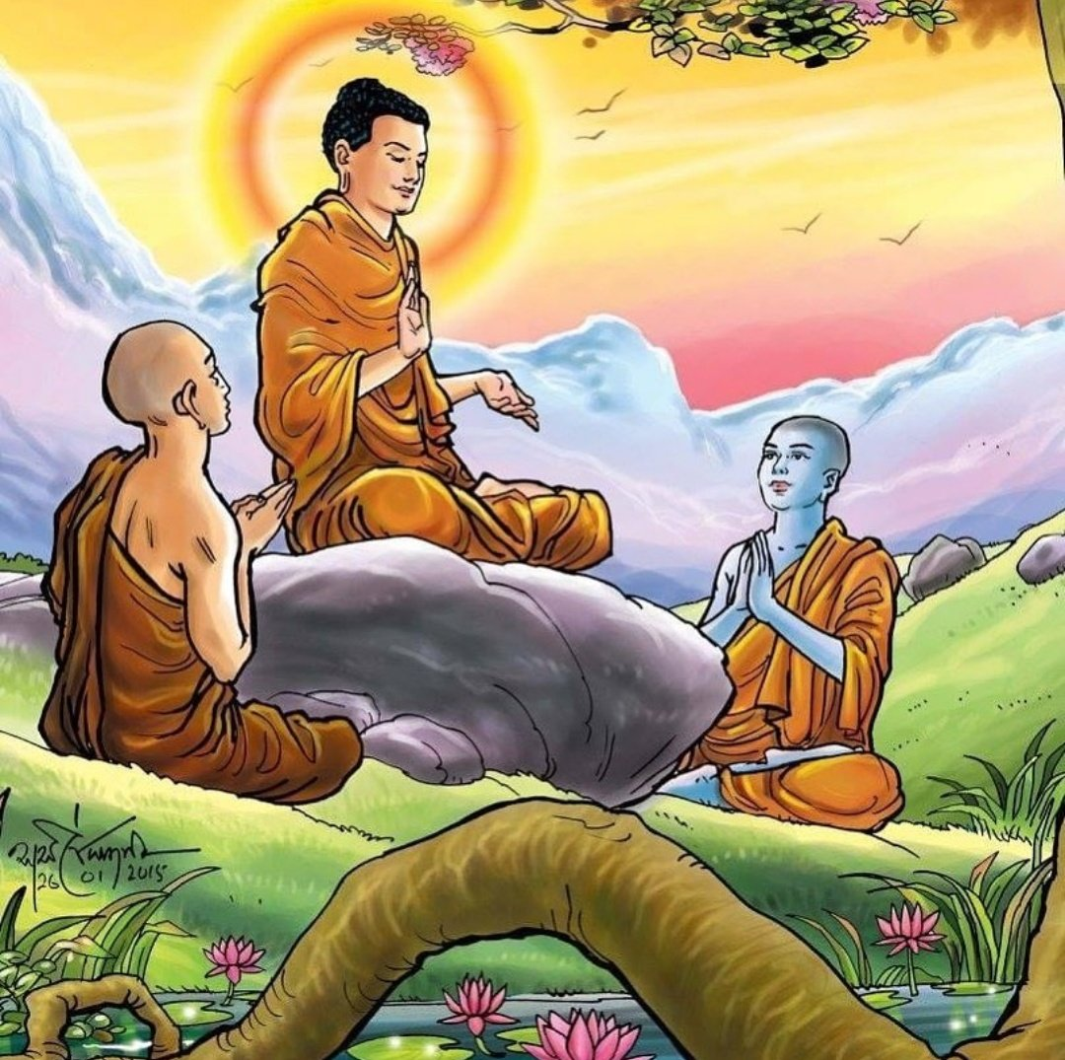

**The Buddha with his two chief disciples: Venerables Sāriputta and Moggallāna [12]**

## A Meaningful Pause at Koṭigāma:A village by the north bank of the Ganges

Continuing the Blessed One’s final journey along the northern bank of the Ganges, we next arrive at Koṭigāma, a quiet village steeped in spiritual significance. As recorded in the *Mahāparinibbāna Sutta* (DN 16), the Buddha said to Venerable Ānanda:  
*“Let us go to Koṭigāma.”*

And thus, with a large Saṅgha of monks, the Blessed One proceeded to Koṭigāma and stayed there.

In *Section 19-2*, we examined several maps illustrating the final footsteps of the Buddha. Among them is a carefully researched map titled *Tathāgatassa Pacchimā Cārikā — The Realised One’s Last Tour* by the respected Buddhist scholar Bhikkhu Ānandajoti. [13] In this map, Koṭigāma is placed near present-day Hajipur, Bihar — situated on the north bank of the Ganges. Interestingly, this is also the region associated with Ukkacelā, which we encountered just before. In modern maps of Bihar, ancient villages like Ukkacelā and Koṭigāma may no longer appear, but tradition places Koṭigāma on the ancient path leading toward Vesāli (Vaishali), approximately 18 km away. (see the Google map given below).

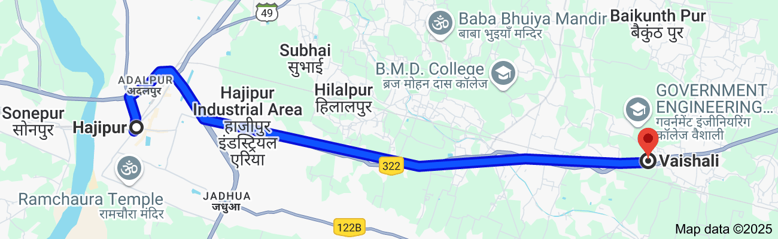

### The Buddha’s Profound Teaching at Koṭigāma

While dwelling in Koṭigāma, the Blessed One, ever-compassionate and mindful of his disciples’ welfare, offered a profound teaching. He reminded the community of monks about the Four Noble Truths, which lie at the heart of liberation. With deep concern for the spiritual progress of the Saṅgha, the Buddha declared:

*“Monks, it is through not understanding, not penetrating* ***the Four Noble Truths*** *that I—as well as you—have for a long time wandered on, caught in the cycle of birth and death.”*

He went on to describe these Four Noble Truths once again:

* The Truth of Suffering
* The Truth of the Origin of Suffering
* The Truth of the Cessation of Suffering
* The Truth of the Path leading to the Cessation of Suffering

By fully understanding these truths, the Buddha said, the root of craving is severed, the fuel for rebirth is exhausted, and the round of saṁsāra comes to an end.

The Blessed One then recited a verse, radiant with insight:

*“Not seeing the Four Noble Truths as they are,  
Having long traversed the round from life to life,  
These being seen, becoming’s supports pulled up,  
Sorrow’s root cut off, rebirth is done*.”[14]

### A Reminder: Morality, Samadhi, and Wisdom

At Koṭigāma, the Buddha also emphasized the essential foundation of the path:  
Sīla (morality), Samādhi , and Paññā (wisdom). These three serve as the pillars for abandoning unwholesome actions and cultivating wholesome ones—by body, speech, and mind. Practised with mindfulness and wise attention (*yoniso manasikāra*), they lead to the development of liberating insight.

With this, the Blessed One continued preparing his disciples for the time when he would no longer be with them **in person—but where the Dhamma and Vinaya would remain as their guiding light.**

## Nādikā—A Village of Realised Devotees

Resuming the northbound journey, the Blessed One, accompanied by the Sangha, departed from Koṭigāma—the serene village nestled along the banks of the sacred Ganges—and made his way to the ancient village of Nādikā, situated on the road to Vesālī. Though absent from the modern-day maps of Bihar, the Nādikā of the scriptures was clearly a place embraced by nature and sanctified by spiritual presence.

The texts tell us that the Buddha stayed there at the Brick House—a rare structure in a village where most dwellings were made of wood. Its very name highlighted its distinctiveness and perhaps its symbolic strength, standing firm amidst a forested landscape.

*“The Lord went with a large company of monks to Nādikā, where he stayed at the Brick House; it says most buildings being of wood, this was exceptional, hence its name.”[15]*

But it was not only the natural surroundings that gave Nādikā its noble character. According to the scriptures, it was home to many lay men and women who ardently and faithfully followed the Dhamma. Even those who had passed away were remembered for their deep realisation—many having attained rebirths in celestial realms, and some, having broken free from the wheel of existence entirely, had realised arahantship.

While the Blessed One was residing in this sacred village, the Venerable Ānanda approached him and humbly inquired about the destinies of those who had passed away. With boundless compassion, the Buddha listed the names of the departed villagers and declared their spiritual attainments—ranging from stream-entry to full liberation. He then concluded with an astonishing revelation:

*“Well over five hundred, by the destruction of three fetters, are Stream-Winners—incapable of falling into states of woe, and certain of attaining Nibbāna.”*

Such a statement illumines Nādikā as more than a village—it was a sanctuary of profound realisation, a field of merit nurtured by the presence of the Tathāgata.

Yet, in his gentle and insightful manner, the Buddha used this moment to offer a deeper teaching to Ānanda. With characteristic grace, he reminded:

“*Ānanda, it is not remarkable that that which has come to be as a man should die. But that you should come to the Tathāgata to ask the fate of each of those who have died, that is a weariness to him…”*

### Mirror of the Dhammma

Instead, the Blessed One offered the Mirror of the Dhamma—a luminous method for self-realisation, where one need not inquire of others but reflect within and know with confidence the path one is on.

*“Therefore, Ānanda, I will teach you a way of knowing Dhamma, called the Mirror of Dhamma, whereby the Ariyan disciple, if he so wishes, can discern of himself:  
‘I have destroyed hell, animal-rebirth, the realm of ghosts, all downfall, evil fates and sorry states. I am a Stream-Winner, incapable of falling into states of woe, certain of attaining Nibbāna.’”*

And what is this Mirror of Dhamma?

It is the possession of unwavering confidence—in the Buddha, in the Dhamma, and in the Sangha. When such faith is deeply rooted, the disciple sees the path clearly and walks it with certainty, secure in the knowledge that liberation is assured.

## Revisiting Vesālī – The Glorious Capital of the Licchavis

The Mahāparinibbāna sutta tell us:  
*“And when the Blessed One had stayed at Nādikā as long as he wished, he departed with a large company of monks and journeyed to Vesālī, where he stayed in Ambapālī’s Mango Grove.”*

With these words, we are transported to the ancient city of Vesālī—once the vibrant capital of the Licchavis, nestled in what is today Bihar, India. Vesālī was not only a cradle of republican ideals—home to one of the earliest known forms of democratic governance—but also a city that shone in the light of the Dhamma. It was here that the Buddha delivered teachings of timeless relevance, leaving behind traces of his boundless compassion and insight. Earlier, the Buddha had praised the Vajjian people, encouraging them to uphold

*“****The Seven Principles of Non-Decline****”*, ensuring their prosperity and longevity. He declared:  
*“As long as the Vajjians uphold these principles, they may be expected to prosper and not decline.”* (DN 16 and Section 19-2)

These principles emphasized unity, frequent assemblies, respect for tradition, protection of the vulnerable, and spiritual reverence—guidelines for noble governance deeply rooted in moral discipline and collective harmony.

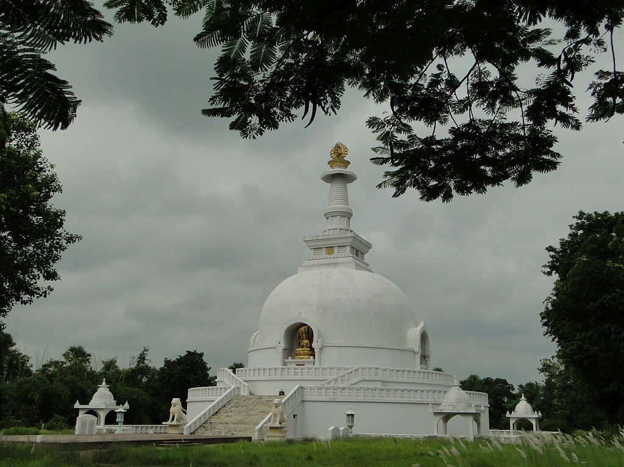

**Modern day stupa in Vaisali [16]**

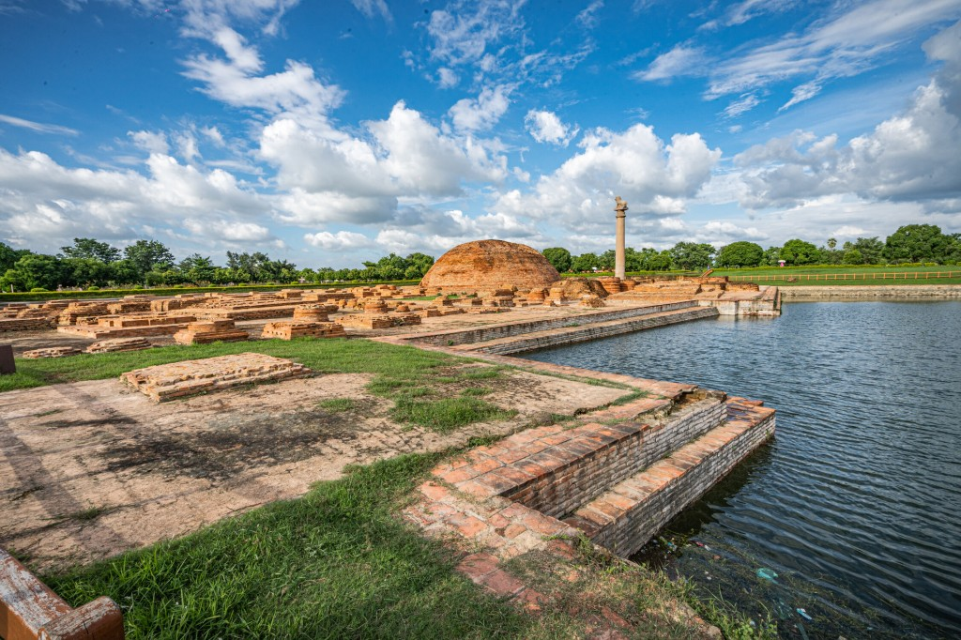

**Ruins of Vaisali- the Ashokan Pillar, Stupa and Ramkund Tank [17]**

### The Sacred Sites of Vesālī

The Buddha's visits to Vesālī were marked by his stays at various significant places—most notably the *Kūṭāgārasālā* or "Peak-roofed Hall" in the *Mahāvana* (Great Wood). Other venerated shrines mentioned in the suttas include the Udena, Gotamaka, Sattambaka, Bahuputta, Sārandada, and Cāpāla shrines—each echoing the footsteps of the Tathāgata and the early Sangha, each sanctified by his presence.[18]

### The Beautiful Courtesan: Ambapālī’s Transformation

Among the cherished stories of Vesālī is that of Ambapālī, the renowned courtesan whose name still resounds with reverence. [19] Appointed by the king and beloved by the people for her beauty and grace, Ambapālī’s life took a profound turn upon encountering the Buddha.

Hearing that the Blessed One had arrived at Koṭigāma, she journeyed with her magnificent retinue in splendid chariots to meet him. After listening to his discourse, her heart was moved with deep faith. She immediately invited the Buddha and the Sangha for a meal the following day—a gesture so earnest that she refused to yield even to the Licchavi princes who sought the same honour. Her devotion triumphed over worldly prestige. *.”[20]*

After offering the meal, she made a magnificent gift—the donation of her mango grove, *Ambapālivana*, to the Buddha and his monastic order. It was a place of rest, reflection, and retreat for the Sangha, and there, the Blessed One gave teachings of great depth.

But Ambapālī’s journey did not end with generosity alone. Renouncing the fleeting pleasures of sensual life, later she ordained as a bhikkhunī and—through deep insight and perseverance—attained Arahantship. Her verses in the *Therīgāthā* still resonate with profound clarity:

*“My body once radiant like a golden image,*  
*now withered, marked by time—*  
*as the Truthful One declared it would be.”*

*“This bag of bones once adorned with beauty,*  
*now a dwelling of decay and pain.*  
*Just as a house falls to ruin,*  
*so too does the body—*  
*and in this I see the truth.”* [21]

Her transformation—from the celebrated courtesan of Vesālī to a liberated Arahant—stands as a shining testimony to the power of the Dhamma to awaken, uplift, and free.



**The body outside used to be so pretty, but it is nothing else just a bag of bones, realizing the truth uttered by the Blessed One, seen the reality of life beautiful Ambapali became a renowned Arahant Bhikkhuni[22]**

### A Timely Teaching at the Mango Grove

While residing in Ambapālī’s grove, the Buddha gave the Sangha a profound and timely admonition—a safeguard for those still walking the path:

*“Monks, a monk should be mindful and clearly aware—this is our charge to you.”*

He detailed the cultivation of sati (mindfulness) and sampajañña (clear comprehension) in every action: walking, sitting, eating, dressing, speaking, even in silence. The instruction was not merely technical; it was a compassionate forewarning. The next day, the Sangha would be welcomed into the home of a woman once famed for her charm and allure. The Buddha, with his infinite wisdom, anticipated the inner challenges some monks might face and offered this teaching as a shield—a way to guard the mind through awareness.

Indeed, in earlier instances too, we hear of monks swayed by worldly beauty, such as in the story of Sirimā (see section 16-2) The Buddha’s teachings were thus not abstract ideals but a living, responsive guidance shaped with compassion and foresight for his disciples’ welfare.

### Conclusion

To revisit Vesālī is to return to a place of luminous history, where the winds still whisper tales of spiritual triumph and transformation. It is a city that welcomed the Buddha with joy, where courtesans became saints, and where the Dhamma took deep root among rulers and citizens alike. Let us contemplate its stories not as distant echoes of the past, but as living inspirations for our own path—reminders that no matter one’s station, beauty, or wealth, liberation lies within reach of a heart turned toward the truth.

With that inspiring words we will end this section. The next section 19-4 will focus the Buddha spending his last rain retreat in a small village of Beluwa in Vajji country.

### Endnotes: Section 19-3

1. DN:16
2. Source: <https://www.royalacademy.org.uk/art-artists/work-of-art/part-of-the-city-of-patna-on-the-river-ganges>
3. Source: <https://www.holidify.com/places/patna/river-ganga-sightseeing-3224.html>
4. Source: <https://southeastasianlibrarygroup.wordpress.com/wp-content/uploads/2014/11/or_5757_f023r1.jpg>
5. DN:16
6. Source: <https://www.justdial.com/Patna/Sabhyata-Dwar-Bankipur-Gandhi-Maidan/0612PX612-X612-220125233757-C1L8_BZDET>
7. Source: <https://en.wikipedia.org/wiki/Sabhyata_Dwar>
8. Source: https://en.wikipedia.org/wiki/Bridges_in_Bihar
9. It says that this incident is recorded in Lalitavistara Sūtra. * The Lalitavistara Sūtra is a Sanskrit Mahayana Buddhist sutra that tells the story of Gautama Buddha from the time of his descent from Tushita until his first sermon in the Deer Park at Sarnath near Varanasi, source: <https://en.wikipedia.org/wiki/Lalitavistara_S%C5%ABtra>
10. Source: <https://www.superstock.com/asset/siddhartha-gautama-known-buddha-enlightened-one-he-crosses-ganges-river/4220-21848595>
11. The commentaries assign the death of Moggallāna to a fortnight after that of Sāriputta. Sāriputta

    expired on the full-moon day of the month Kattika (October-November), Moggallāna on the following new-moon day. For an account of his death, see Hecker, “Moggallāna: Master of Psychic Power,” in Nyanaponika and Hecker, *Great Disciples of the Buddha*, pp. 100-5. See: SN47: Note: 162.
12. Source: <https://damsara.org/dhamma-talks-in-english/ven-panadure-chandaratana-thero/sutta_teachings_in_english/moggallana-samyutta-28-08-2024/>
13. Source: <https://ancient-buddhist-texts.net/Maps/During-Buddhas-Time/Map-05-Last-Tour.htm>
14. DN:16
15. Ibid.
16. Source: <https://commons.wikimedia.org/wiki/File:Vaishali,_Bihar.JPG>
17. Source**:**<https://tourism.bihar.gov.in/en/destinations/vaishali>
18. Source**:**<https://tourism.bihar.gov.in/en/destinations/vaishali>
19. She is said to have come spontaneously into being at **Vesāli** in the gardens of the king. The gardener found her at the foot of a mango tree — hence her name — and brought her to the city. She grew up so full of beauty and of grace that many young princes vied with each other for the honour of her hand. Finally, in order to end their strife, they appointed her courtesan. <https://www.aimwell.org/DPPN/ambapali.html>
20. <https://suttacentral.net/define/ambap%C4%81l%C4%AB?lang=en>
21. Thgi:13: 252
22. Picture sources: <https://siriyasodaraseya.com/enlightened-nun-arahant-nun-> & <https://www.tatsbase.com/products/1718574873-tattoo-template-of-a-female-skeleton-with-a-rose-and-long-hair>